Title: Engineering Design Challenges
Students Name:
Institution Affiliation:

Background and Overview
The National Aeronautics and Space Administration has been a key pillar of exercising engineering as a core entity in developing space crafts (Ares vehicles) and other operational gears. Over the years, it has been in to practice that all space vehicles should have a thermal protection system (TPS). The directive was in place as a template (NASA-TPS, 2007), in order to maintain the heat emitted during launching, exhaust plumes of the engine and from the atmospheric friction.
However, despite the numerous researches on developing an effective TPS, there is a demanding need for better models and baseline measurements that could improve the way a thermal protection system works (solely to protect the interior parts of the crafts). This builds up our main research application on the different ways the modeling techniques can be modified.
Analysis Approach
The analysis can be approached from various angles. To start with, it is very important to have an understanding of how TPS works and the requirements needed in simulating the same. During, NASA assembly of TPS, the methods tend to be time consuming and expensive in the long run, due to the multiple tests needed for validation. In our case the approach has to be narrowed down into manageable concepts, which are cheap, safe and effective. The analytical approach has to internalize how heat is transferred during the heat-based processes. This will generally show case possible fundamental theories of thermal conductivity that can be of help in developing an effective TPS.

For an all-round Thermal Protection System, it is crucial to consider how long and how much heat the model take, without altering the space crafts. The whole idea of time has everything to do with the project. NASA Ares vehicles are underway for passenger transportation. With this, adventure is unlikely to seize, and one has to be assured for how long the heat insulation would take. The analogy has to be as far as the vehicle can get. Basically, our approach is in need to have different models with different types of material that have tolerable physical and chemical properties.
Apart for the exterior and interior representation of a space vehicle, other factors like speed which apply on real life space craft have to in place as well. The concept must be tested under different temperature (frictional temperature α speed).
Analysis
Shielding of heat by TPS is a compilation of insulators that control heat at different stages from different sources of heat. For example, there are different insulators on engines (fuel combustion), external body (friction with air) and the base (point of reactions with atmospheric gases). All these areas have different systems.
To start comprehensively with our experiment, thermal conductivity and heat capacity are one of the major factors in play when choosing the right model for a Thermal Protection System, regardless of the heat source. Simply it is important to understand how a material transports heat internally and for how long it can hold heat. Conclusively the major aspect that bridges thermal conductivity and heat capacity of a material is précised by its thermal capacity; ability of a material to absorb a lot of heat without them are heated up very much.
According to Douglas C (1994), a good conductor is not necessarily a good heat holder. The table below shows Water has a very high specific heat, but only with unassertive thermal conductivity. Equally, associate silver and aluminum. Silver has more than twice the thermal conductivity of aluminum, but has only 1/4 the specific heat. Basically, silver would make a better thermal conductor and aluminum would make a better heat holder. Comparing aluminum with copper, aluminum has about 2.5 times the heat-absorbing capacity of copper. It must absorb approximately 2.5 times the heat energy as the same mass of copper before its temperature increases by 1.0°C.
 | Thermal Conductivity | Specific Heat (Thermal Capacity )
Substance | (Joules/s × m × °C) | (kcal/g × °C)
Silver | 420 | 56
Copper | 380 | 93
Aluminum | 200 | 220
Steel | 40
Glass | 0.84 | 200
Brick and Concrete | 0.84
Water | 0.56 | 1000
Human tissue without blood | 0.2 | 830
Asbestos | 0.16
Wood | 0.12 | 400
Cork and Glass wool | 0.042
Down | 0.025
Air | 0.023

Having a given substance with its mass and specific heat it is possible to determine its heat absorbing capacity. (Heat absorbing capacity of a given quantity is proportional to its mass times its specific heat). For example; when a Thermal Protection System contains 5 grams of copper, its heat absorbing capacity would be 5 g × 93 kcal/g × °C = 465 kcal / °C (energy per degree). However, in out Thermal Protection challenge it is preferably to use low temperature glue as our TPS mold for safety purposes.
Requirements
Torch, fuel bottle, hot melts glue, screws, base-wood, ring-stand, paperclip, wooden dowel, stop block, stop watch and a pencil.
Methodology
- Design, Building and Testing
The first step is to assemble the TPS models as shown. At least three samples in a row.

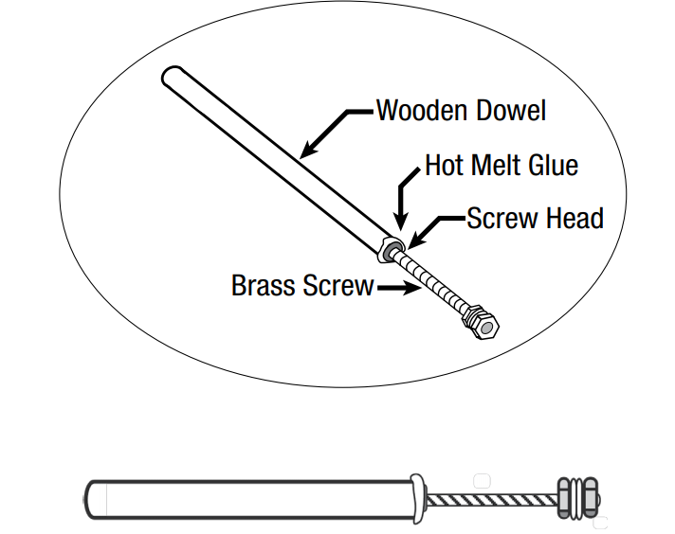

Secondly, hold the assembled TPS with the ring stand at a slanting position towards the torch flame. Slide the stand up to the stop block point. (6-8 inches from the flame). Once the hottest part of the flame torches the tip of the screw, start the stop watch. Stop the watch when the screw falls. Slide the other modules and repeat the same process as shown below.
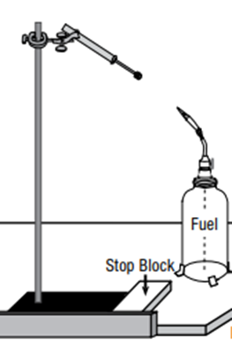
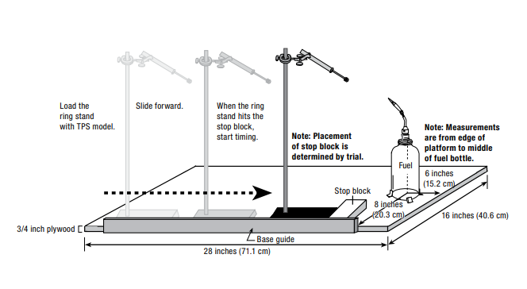

Recording Data
The data is recorded as time taken for each screw to fall off from the point of heating.
Test | Start | Stop | Time Taken
1 | 00:00:00 | 00:00:34 | 3.4 seconds
2 | 00:00:00 | 00:00:37 | 3.7 seconds
3 | 00:00:00 | 00:00:41 | 4.1 seconds

The flame length was measured using a paperclip.
Flame length = 10-15mm
Torch length = 60 mm (6 cm)
Analyzing Results
The average time taken is
3.4+3.7+4.1 = 3.7 seconds
3
3.7 seconds is within the possible range of 3 to 6 seconds.
The direct proportional graph of torch length verses time taken for the TPS model to fall should look as follows:
 | Time Taken (seconds)
Distance (mm) | 3.7 sec | 6 sec (max)
Distance (mm) | 60 mm | 97.30 mm (max)

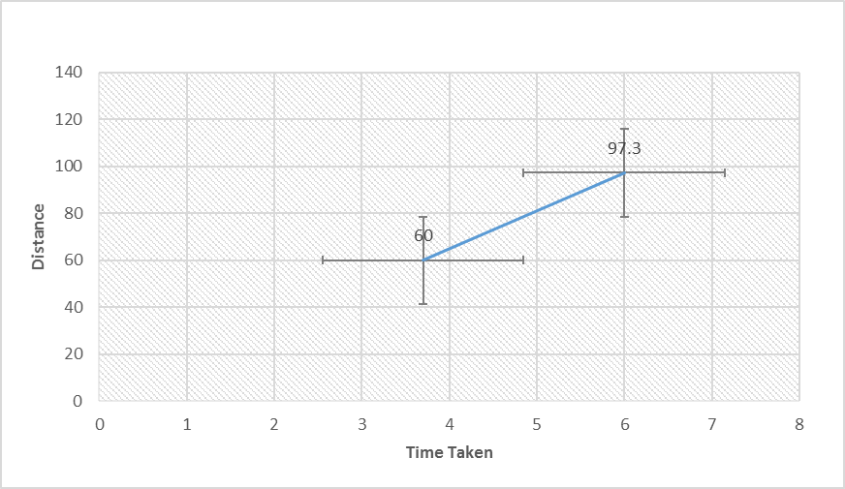
Conclusion
From the discussions above it is indeed possible to have a comprehensive module that can locally test materials if they are suitable candidates of Thermal Protection System for both Space crafts and the new Ares vehicle project. Despite the risk of testing other reactive materials (other than low temperature glue), it would be best for NASA to invest on a similar concept which safer mechanism. Basically the test process cuts the cost incurred on industrial test and the time taken to verify the practicability of possible TPS components.
Question 1
mx" + bx' + kx = 0
m = 15000 kg
Acceleration due to gravity on moon, g = 1.6 m/s/s
Acceleration due to gravity on mars, g' = 3.7 m/s/s
Now,
mg = kxo
xo = 0.5 m
hence
k = mg/xo = 48000
also, b = 48,000
hence
15,000x" + 48,000x' + 48,000x = 0
hence
5x" + 16x' + 16x = 0
Question 2
at t = 0
x'(t = 0) = 2 m/s
so on moon, the equation of motion can be derived as under
consider b^2 – 4
mk < 0
hence
the oscillation is under damped
for under damped oscillator
x = e^(-gamma*t) *a*cos (w't - alpha)
w' = square root (k/m - gamma^2)
gamma = b/2m = 1.6
hence
w' = 0.8 rad/s
hence
x = e^(-1.6t) a*cos (0.8t - alpha)
now at t = 0, x = 0

hence
0 = a*cos(alpha)
also, x' = e^(-1.6t) a*(-0.8sin (0.8t - alpha)) - 1.6*e^(-1.6t) *a*cos (0.8t - alpha)
x' = e^(-1.6t) a*[(-0.8sin (0.8t - alpha)) - 1.6*cos (0.8t - alpha)]
x'(t = 0) = 2 m/s
2 = 0.8*a*[sin(alpha)) - 2*cos(alpha)]
2.5 = a*sin(alpha) - 2a*cos(alpha)
a*sin(alpha) = 2.5
a*cos(alpha) = 0
hence
alpha = pi/2
a = 2.5
hence
Equation of motion on moon
x = 2.5 *e^(-1.6t) *sin(0.8t)
Question 3
The following plot shows the variation of x with t
so for all t > 0, maximum compression is less than 0.5 m
Hence the lander is not in danger of bottoming out.

Graph representation of equation of motion.
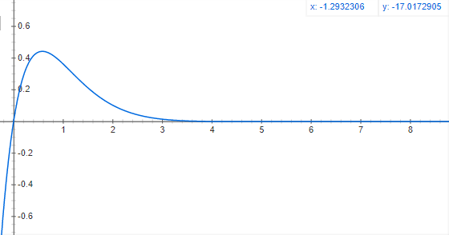
Question 4
Martian Gravity- as the values of m, k and b remain the same, the equation of motion dictates similar amplitude.
Question 5
The change of gravitational force in Mars reads close to twice that of moon, but those changes nothing on the amplitude. Hence the spacecraft will not bottom out on the mars gravity as well.
Question 6
The concept has no viable changes to make, thus the landing is safe despite the variance in gravitational force.

References
Brian Dunbar, NASA (2007), Journal on Engineering Design Challenges: Thermal Protection Systems Educator Guide. Last Modified on June 16, 2017. https://www.nasa.gov/audience/foreducators/topnav/materials/listbytype/EDC_TPS.html
Dwayne A. (2011), Article on Shuttle Thermal Protection System (TPS) https://www.centennialofflight.net/essay/Evolution_of_Technology/TPS/Tech41.htm
Robert LA Salvia (2017), Webpage on Glenn Engineering Design Challenges https://www.nasa.gov/glenn-engineering-design-challenges

